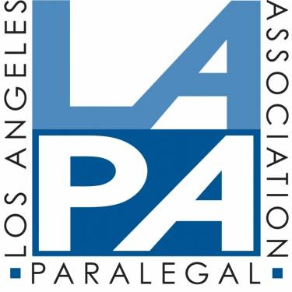
2021 LAPA Lifetime Achievement Award (LAA) Criteria
and Application

Please submit completed application by October 5, 2021.

CRITERIA
The eligibility criteria for LAA recipients include (i) dedication to the development, strengthening and advancing the paralegal profession, (ii) contributing to the growth and development of the Los Angeles Paralegal Association, and (iii) community involvement within the legal community and/or the larger community.

1. DEDICATION TO THE DEVELOPMENT, STRENGTHENING AND ADVANCEMENT OF THE PARALEGAL PROFESSION
The recipient must have at least ten years of legal and/or community related experience. The recipient may be, but not limited to, a paralegal, educator or attorney. Each recipient of the LAA must show positive promotion of the paralegal profession within the legal community through their initiative, participation and leadership.
The recipient may have played a significant part in creating, developing, and or promoting an important and distinctive program, which positively affects the growth of the paralegal profession. Examples include development of a CLE committee or leadership seminar or special event, paralegal education such as teaching, publishing a book, establishing an ABA approved paralegal program, development of a paralegal career enhancement program, or a legislative or policy decision that affects the paralegal profession.

2. CONTRIBUTING TO THE GROWTH AND DEVELOPMENT OF THE LOS ANGELES PARALEGAL ASSOCIATION
The recipient of the LAA must have contributed to the growth and/or support of LAPA. Membership in LAPA is not required, however, all classes of LAPA membership, except student, are eligible, including voting, associate, and benefactor. Involvement may include, but is not limited to, participation as an Officer or member of the Board, Committee chairperson, or volunteer speaker for one of LAPA's events such as the October Conference. Other examples include leadership roles, assumed as a member of LAPA for affiliated associations or organizations supporting the paralegal profession.

3. EXTENDED COMMUNITY INVOLVEMENT
Each recipient of the LAA must show an active role in providing, creating or promoting volunteer services for the benefit of a pro bono organization or a community service inside or outside of the legal profession.

Please submit the completed application by no later than October 5, 2021 via e-mail to admin@lapa.org or samantha@marjiya.com.

Name, e-mail address, and telephone number of the person you are nominating:

Your name, e-mail address, and telephone number:

Below each listed section, please describe how your nominee qualifies for this award. Please add or attach additional documentation as needed.

I. DEDICATION TO THE DEVELOPMENT, STRENGTHENING AND ADVANCEMENT OF THE PARALEGAL PROFESSION

II. CONTRIBUTING TO THE GROWTH AND DEVELOPMENT OF THE LOS ANGELES PARALEGAL ASSOCIATION

III. EXTENDED COMMUNITY INVOLVEMENT

