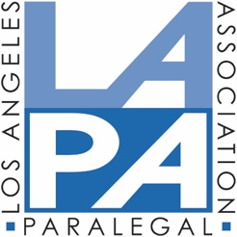

AFFIRMATION OF RECORDED WEBINAR
I, __________________________________________, declare under penalty of perjury
(print name)
under the laws of the State of California that I watched the following webinar:
______________________________________________________ held on ________________________
(name of webinar) (date of webinar)
taught by __________________________________, in its entirety on ____________________.
(name of instructor) (date listened)

Date:_______________________ ____________________________________

AFFIRMANT (Signature) ____________________________________________

Please return this form by email:
LAPA Education Chair
Email: admin@lapa.org
NOTE: AN AFFIRMATION MUST BE SUBMITTED FOR EACH RECORDED WEBINAR FOR MCLE PURPOSES

